|  |  |
| --- | --- |
| cetlogo ***CHEMICAL ENGINEERING TRANSACTIONS***  ***VOL. xxx, 2025*** | A publication of  aidiclogo_grande |
| The Italian Association  of Chemical Engineering  Online at www.cetjournal.it |
| Guest Editors: Bruno Fabiano, Valerio Cozzani  Copyright © 2025, AIDIC Servizi S.r.l. **ISBN** 979-12-81206-xx-y; **ISSN** 2283-9216 | |

Regulatory proposals for non-Seveso establishments

Agnieszka Gajek

Central Institute for Labour Protection – National Research Institute, Czerniakowska 16, 00-701 Warsaw, Poland

agnieszka.gajek@ciop.pl

For establishments subject to the requirements of the Seveso III Directive, i.e. establishments with a high or increased risk of a major industrial accident (so-called Seveso establishments), the legal requirements set out in the Directive apply. A separate group of establishments are those which are not lower- or upper-tier establishments, but which nevertheless pose a risk of events equivalent to a major industrial accident. These establishments can be called non-Seveso establishments.

On the basis of the requirements for upper-tier and lower-tier establishments in the Seveso III Directive, legal requirements have been prepared for non-Seveso establishments covering eligibility criteria, an Major Accident Prevention Policy and a Safety Management System.

The proposed legislation also addresses the issue of supervision and inspection by the competent authorities. The first procedure relates to the qualification of an establishment, so qualification criteria have been proposed to determine whether an establishment falls into the non-Seveso category. With regard to the Major Accident Prevention Policy, the greatest emphasis was placed on establishment management awareness of the hazards posed by the establishment and the potential impact on local residents and informing them of the risks and how to act in the event of a major accident. As the Major Accident Prevention Policy must be implemented through a Safety Management System, the requirements for such a system have been developed.

* 1. Introduction

According to the definition of a major accident in the Seveso III Directive (Seveso III Directive, 2012):

*major accident’ means an occurrence such as a major emission, fire, or explosion resulting from uncontrolled developments in the course of the operation of any establishment covered by this Directive, and leading to serious danger to human health or the environment, immediate or delayed, inside or outside the establishment, and involving one or more dangerous substances;*

In accordance with EU legislation, a major accident can only occur during the operation of a Seveso establishment, which is defined as an establishment subject to the requirements of the Directive and characterised by either limited or high risk (lower and upper tier). As a consequence of the Directive's implementation by individual Member States into their respective national legal orders, the specific legal requirements may differ between countries. This situation has been criticised on in many publications, including Laurent et al., (2021), Kotek at al. (2024). Differences in applicable national law have a direct impact on the application and quality of enforcement of major-accident prevention legislation in individual Member States. In accordance with Polish legislation (Polish Parliament, 2024), a major accident may occur in any establishment, not merely those designated as lower or upper tier.

It is also noteworthy that Annex VI of the Seveso III Directive provides that accidents involving at least 5% of the threshold quantity that qualifies an establishment for the upper-tier category must be reported to the Commission. This is defined as “*Any fire or explosion or accidental discharge of a dangerous substance involving a quantity of at least 5 % of the qualifying quantity laid down in Column 3 of Part 1 or in Column 3 of Part 2 of Annex I*”. However, a release of 5% of the threshold quantity may not only occur in upper or upper-tier establishments. There is a significant group of establishments where quantities of dangerous substances are present in less than the set thresholds for lower-tier establishments, meaning that these establishments are not subject to the requirements of the Directive. In these facilities, a fire or a release of a quantity equal to or exceeding 5% of the threshold for a high-risk facility may occur. In addition, there are a number of establishments that have slightly smaller quantities of hazardous substances on their premises than the thresholds set in the Directive. A release of 5 tonnes of acute toxic substances, and 4.9 tonnes if conditions are unfavourable, could result in significant adverse effects for both the facility itself and its surroundings.

In light of the effects outlined in Annex VI of the Seveso III Directive, it is also pertinent to consider the presence of other chemicals commonly found in chemical plants, such as inorganic acids and alkalis. The presence of such substances will not result in an establishment being categorised as a Seveso establishment. However, the release of large quantities of such substances may also result in the effects described in Annex VI of the Seveso III Directive. According to Polish law, release into the environment – as a result of an accident – of large masses of these substances will also be classified as a major accident (Gajek, Michalik, 2013).

In these circumstances, it can be assumed that non-Seveso plants can be:

* Establishments not classified as lower-tier due to the relatively lower amounts of substances than in the qualifying criteria set out by Seveso II Directives (“sub-threshold” quantities).
* Establishments with large quantities of substances classified as corrosive (Skin Corr.), including acids and alkalis, irritant (Skin Irrit., Eye Irrit.) and others, not included in the criteria of Seveso III Directive.
  1. Requirements for non-Seveso establishments

Non-Seveso establishments are often located close to dense urban areas, making the people living in the area around the establishment potential victims of an industrial accident. In the case of this group of plants, there is no obligation to inform nearby residents on how to behave in the event of the release of large quantities of hazardous substances. It is worth mentioning the 1984 Bhopal accident, where the victims of this most tragic accident were people living in the vicinity of the plant. Obviously, in Bhopal the scale of the tragic consequences was enormous due to the quantities of hazardous substance (ICHEME, 2024).

This is why it is so important to determine which establishments will be classified as non-Seveso (‘qualification criteria’), and then to prepare requirements for both an accident prevention policy and a safety management system appropriate to the hazard posed by the establishment. The issue of adequate control by the relevant authorities is also not without significance.

* + 1. Qualification criteria

At the beginning, it is necessary to answer the question of which establishments should be classified as non-Seveso establishments. This means establishing the qualifying criteria, i.e. the limit quantities of hazardous substances present or likely to be present in the establishment that will cause the establishment to be categorised as non-Seveso. It is important to find an appropriate compromise so that not every establishment with small quantities of hazardous substances is immediately a non-Seveso establishment, but at the same time that establishments that pose a serious risk are included in this category (Figure 1).

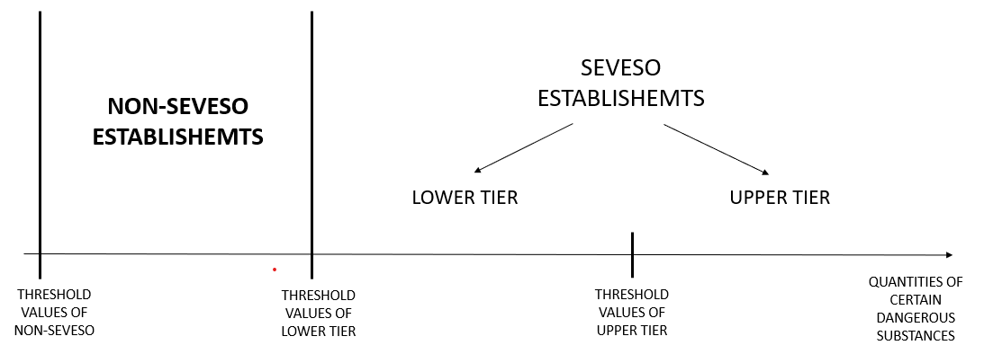

Figure 1: Relationship between Seveso and non-Seveso establishments (own drawing)

The qualifying criteria should be defined in a manner that is unambiguous and unquestionable, while simultaneously providing no grounds for questioning either the method of their establishment or the values themselves. Annex I of the Seveso III Directive was therefore used as the basis for establishing the threshold values.

An attempt was made to use simulations of major accidents (releases of dangerous substances and fires of flammable substances) using the BREEZE computer program as a basis for modifying the qualifying criteria. A variety of input parameter combinations were tested, including both average temperature values and extreme values (lowest and highest) observed in Poland during 2022. These values were used in conjunction with constant other parameters. In Poland, the highest temperature value of 38.3°C was recorded in 2022 (19 June in Słubice), while the lowest temperature value at 2 m level of -18.6°C was recorded on 14 December in Zamość. The discrepancy in the simulation results was expected and not surprising, so this approach was abandoned.

In addition, by analysing the upward trend in temperature over the last few years (https://climate.copernicus.eu/), it was concluded that changing the threshold values based on current weather conditions might not be reliable and could be easily challenged.

Various combinations were also tested for proposing threshold values, including using an analogous difference between non-Seveso and lower tier threshold values as between lower tier and upper tier. However, negative values were obtained in some cases, which led to a departure from this proposal.

In the end, four combinations of thresholds representing 2 and 5 % of the thresholds were selected to qualify the plant for lower tier and for upper tier. The percentage provisions in the directive were used. The provision for 2 % can be found in Annex I in Note 3 and the provision for 5 % in Annex VI in section 1.1. Threshold values were calculated for all categories of hazardous substances and named dangerous substances. Examples of thresholds for substances with acute toxic effects (Division H) are given in Table 1

Table 1: Proposed thresholds for categories of substances with acute toxic effects

|  |  |  |  |  |  |  |  |
| --- | --- | --- | --- | --- | --- | --- | --- |
| Hazard categories in accordance with Regulation (EC) No 1272/2008 | Qualifying quantity (tonnes) of dangerous substances as referred to in Article 3(10) for the application of | |  | OPTION 1  5 % of the existing threshold value for | | OPTION 2  2 % of the existing threshold value for | |
| Lower-tier requirements [Mg] | Upper-tier requirements [Mg] |  | Lower-tier requirements [Mg] | Upper-tier requirements [Mg] | Lower-tier requirements [Mg] | Upper-tier requirements [Mg] |
| Section ‘H’ – HEALTH HAZARDS | | | | | | | |
| *H1 ACUTE TOXIC* | 5 | 20 |  | 0,25 | 1 | 0,1 | 0,4 |
| H2 ACUTE TOXIC | 50 | 200 |  | 2,5 | 10 | 1 | 4 |
| H3 STOT SPECIFIC TARGET ORGAN TOXICITY – SINGLE EXPOSURE STOT SE | 50 | 200 |  | 2,5 | 10 | 1 | 4 |

In view of the occurrence of other hazardous substances in substantial quantities in non-Seveso establishments, the hazardous substances present in Poland in non-Seveso establishments were analysed. The databases of the Polish control and supervisory authorities (State Fire Service and Environmental Protection Inspectorate) were used for identification. Both individual substances and groups of chemical substances were identified. These data are presented in Table 2.

Table 2. Grouped substances and mixtures most frequently encountered in non-Seveso establishments (more than 100 times) – data received from the State Fire Service, 31.12.2021 (Gajek A., 2024)

|  |  |
| --- | --- |
| Name of the chemical substance and group of substances | Number of plants where a given substance is present |
| ammonia (including ammonia solution) | 531 |
| inorganic acids (including hydrochloric acid, sulfuric acid, nitric acid, phosphoric acid, hydrofluoric acid) | 480 |
| oil and petroleum products (including gasoline, diesel fuel, crude oil, kerosene, heating oil, engine oil, turbine oil, transformer oil) | 349 |
| hydroxides (including sodium, potassium and calcium hydroxides) | 213 |
| chlorine compounds (including sodium hypochlorite, chlorine, potassium chlorate) | 198 |
| propane-butane (LPG, propane) | 169 |
| alcohols (including ethanol, methanol, isopropanol, butanol, isobutanol) | 159 |

However, in order not to be limited to specific chemicals present at non-Seveso sites in Poland this year, it was decided to include a general entry for inorganic acids and alkalis into the qualification criteria being developed for non-Seveso sites. Taking into account the level of hazard and the thresholds for acute toxic substances and substances hazardous to the aquatic environment, the thresholds proposed are analogous to those for category E2 (hazardous to the aquatic environment in category chronic 2).

* + 1. Notification

As in the case of upper and upper-tier establishments, non-Seveso establishments should be required to register with the inspection and supervisory authorities. In Poland, the inspection and supervisory institutions for the prevention of major industrial accidents (State Fire Service and Environmental Protection Inspectorate) maintain independent lists of non-Seveso establishments for their needs, but the qualification criteria used by both institutions are different, resulting in significant discrepancies in the lists. The inspection and supervisory body to which non-Seveso establishments could notify their establishment could be the Labour Inspectorate, as a control and supervisory body for the observance of working conditions. It would not be reasonable to impose a single appropriate solution regardless of the Member State.

Considering that non-Seveso establishments are mostly small and medium-sized enterprises and the nature of the hazards is much smaller, the notification document for a non-Seveso establishment could be very limited and, based on the requirements of the directive, could contain only the necessary minimum information, e.g:

1. the name or trade name of the operator of the establishment and the full address of the establishment concerned;

2. sufficient information to identify the dangerous substances and category of substances concerned or likely to be present at the establishment;

3. the quantity and physical form of the dangerous substance or substances concerned;

4. the activities or proposed activities carried out within the installation or storage facility;

5. the immediate surroundings of the establishment and factors likely to cause a major accident or to aggravate its consequences.

* + 1. Major-accident prevention policy

Major-accident prevention policy (MAPP) with a safety management system (SMS) should be the basis for preventing accidents with effects comparable to those of a major industrial accident. In Poland, such facilities are sometimes located in forested areas far from human habitats, as well as in dense urban areas (Figure 2). The consequences of major accidents depend very much on the location of the establishment and will be very different in unpopulated, rural and urban areas. This is why the surroundings of establishments are so important.

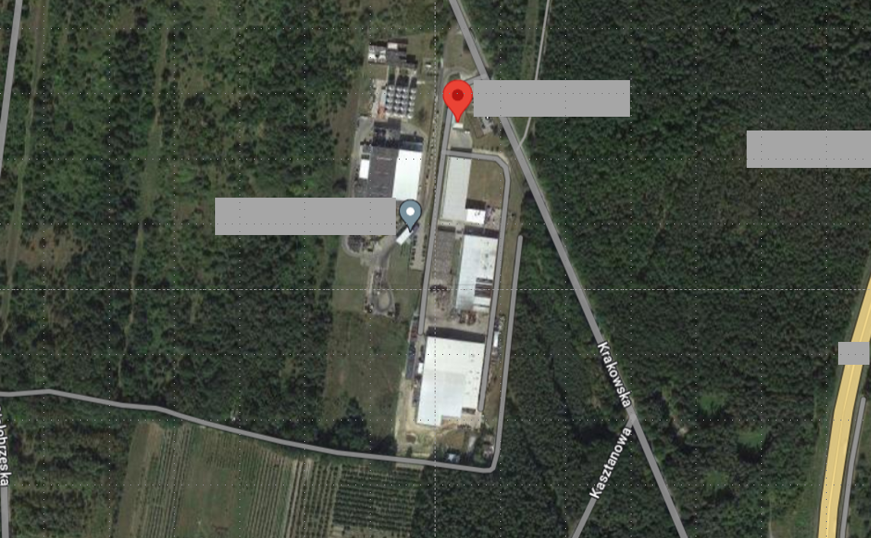 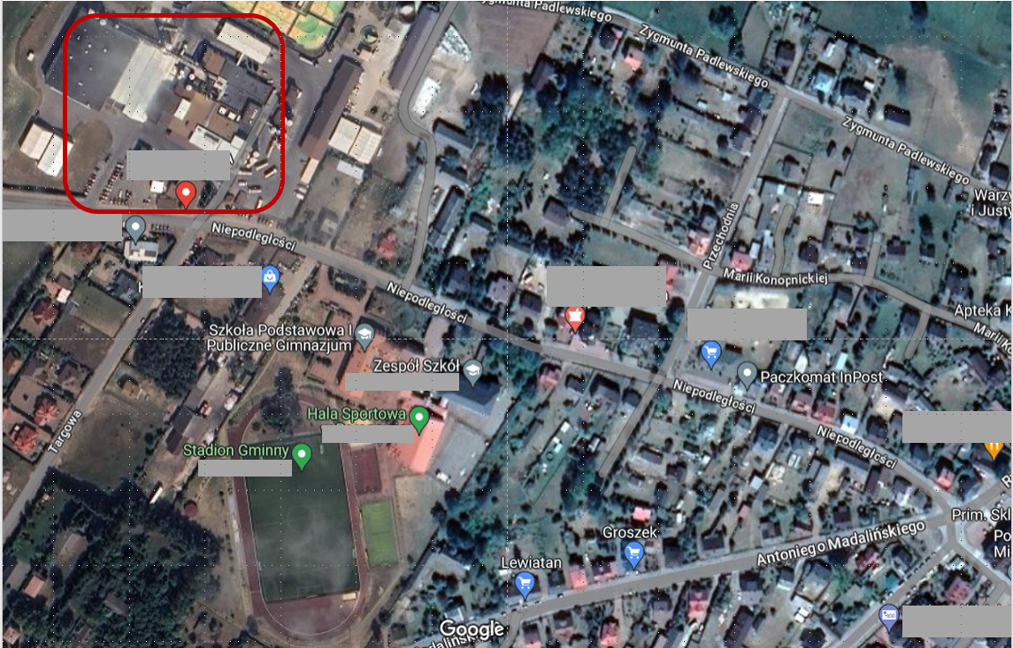

Figure 2: Examples of non-Seveso plant locations in Poland (gogle.maps.pl)

Therefore, the priority of the policy prepared by a non-Seveso plant should be awareness of the risks posed by the plant and the desirability of prevention and mitigation of industrial accidents. The leadership of the plant operator is crucial in this case. Otherwise, documentation may be prepared whose only function is to meet legal requirements. Unfortunately, there are situations where the policy is prepared by external companies, or by plant employees, and the awareness of the plant operator is limited to a signature only. Therefore, the requirements for an accident prevention policy (APP) should be very short, while at the same time obliging to demonstrate awareness of the hazards posed by the establishment. Based on the provisions in the Polish legislation (Polish Parliament, 2024), specific requirements for non-Seveso establishments have been proposed:

1. The operator of a non-Seveso establishment shall draw up a written APP.

2. The operator of a non-Seveso establishment shall implement the APP by means of a SMS guaranteeing a level of protection for persons and the environment appropriate to the risks, as part of the establishment's overall management system.

3**.** APP shall take into account the risks of industrial accidents and the complexity of the organisation at the establishment.

4**.** APP shall include:

a) the objectives and principles of action of the operator to prevent accidents from occurring and to limit their consequences if they do occur;

b) an indication of the tasks and responsibilities of the management of the establishment, in terms of controlling accident hazards and ensuring a level of protection of persons and the environment appropriate to the hazards;

In connection with the issue of the location of the establishment in the surroundings of people's living and dwelling places, it is worthwhile for the policy to include provisions concerning the information of the population, e.g.

c) indicating the tasks and responsibilities of the management of the establishment with respect to informing the local community about how to behave and behave in an emergency situation.

* + 1. Safety Management system

SMS for non-Seveso plants, by definition, does not need to be as complex as for Seveso plants. However, it should include such key elements as activities on emergency procedures and training e.g:

SMS should include:

1. determination, at all levels of the organisation, of the responsibilities of the employees responsible for emergency response;

2. determination, at all levels of the organisation, of the measures to be taken to raise awareness of the need for continuous improvement in emergency response;

3. determination of emergency response procedures;

4. determination of the training programme and provision of training for employees, responsible for emergency response, and for other persons working in the plant, including subcontractors;

5. determination of mechanisms to verify the continuity of the chain of communication and emergency response procedures;

6. determination of procedures for providing information to local residents on how to behave and act in the event of an accident.

At the installation level, procedures are required to enable the correct operation of the installation, i.e.

7. instructions for the safe operation of the installation where the dangerous substance is present, for normal operation of the installation and for maintenance and temporary shutdowns

8. instructions on how to proceed in the event of necessary changes in the industrial process;

9. performance monitoring of the installation where the dangerous substance is present, taking into account best available practice, in order to take corrective action in the event of phenomena which deviate from the normal operation of the installation, including wear and tear of the installation and corrosion of its components.;

In addition, it would be good, if possible, to have elements such as

10. the operation of mechanisms for systematic analysis of the risks of industrial accidents and the probability of their occurrence;

11. a systematic analysis of foreseeable situations that could lead to industrial accidents;

12. a systematic assessment of APP and SMS from the point of view of their validity and effectiveness, indicating how they are documented and approved.

Of course, these are not all the requirements for SMS. Suffice it to mention that in Annex III of the Seveso III Directive, the system addresses issues such as organisation and staffing, identification and assessment of major hazards, operational control, management of change, emergency planning, control of performance and audits and reviews. However, it cannot be expected that all of these elements will be implemented in all small and medium-sized non-Seveso establishments. It would be worthwhile for them to be included, even if to a very limited extent.

* 1. Competent authority

An important element of the whole major-accident prevention system is the functioning of the competent authorities in charge of inspection and surveillance activities. To support these authorities, a checklist has been prepared to facilitate the verification of the correctness of the major-accident prevention system for establishments not covered by the Seveso Directive. Use has been made of the Guidance on inspections as required by article 18 of the Council Directive 96/82/EC (Seveso II) (European Commission, 1999) prepared under the aegis of the European Commission. It is not a new document and refers to an earlier version of the Directive (the Seveso II Directive), but retains the essence of the problem. The changes made are related to the need to emphasise information to the public.

* 1. Guidelines

In addition to the legislation itself, in the case of small and medium-sized enterprises, which are often not establishments, it is important to develop guidelines for both establishments and inspection and control bodies. In the case of establishments, due to the very small number of employees, it is important to guide the operator of the establishment in a simple way through the requirements of the legislation. In the case of inspection and control bodies, it is important to point out that the requirements are not the same as those for Seveso establishments.

* 1. Conclusions

Based on the requirements for upper-tier establishments in the Seveso III Directive, legal requirements for non-Seveso establishments have been prepared, covering both the qualification criteria, APP and SMS. The proposed legislation also addresses the issue of supervision and inspection by the relevant competent authorities. The first procedure relates to the qualification of an establishment, so qualification criteria have been proposed to determine whether an establishment falls into the non-Seveso category. In many cases, the 5% criterion has been used and zones of influence have been defined for the most common dangerous substances. With regard to APP, the main focus has been on raising management awareness of the hazards posed by the site and the potential impact on local communities, informing them of the risks and what to do in the event of a major accident. As APP needs to be implemented through SMS, the requirements for such a system have been developed. It is important to take into account the complexity of the establishment and the variety of dangerous substances used in it. The draft legislation outlined here can provide a starting point for discussion of non-Seveso establishments and the hazards they pose.

Acknowledgments

This paper was created on the basis of results of a research task carried out within the scope of the 6th stage of the National Programme “Governmental Programme for Improvement of Safety and Working Conditions”, funded by state services of the Ministry of Family, Labour and Social Policy (under the name of the Ministry of Family and Social Policy prior to December 12th, 2023). Task no. 3.ZS.10 entitled “Analysis and assessment of major-accident hazards in non-Seveso establishments”. The Central Institute for Labour Protection – National Research Institute is the Programme’s main co-ordinator.

References

European Commission: Joint Research Centre, Porter, S. and Papadakis, G., *Guidance on inspections as required by article 18 of the Council Directive 96/82/EC (Seveso II)*, Publications Office, 1999,

Gajek A., 2024, Non-Seveso establishments – plants posing a risk of a major industrial accident, Bezpieczeństwo pracy. Nauka I praktyka 9(636), 8-11 DOI: 10.54215/BP.2024.9.19.Gajek (in Polish)

ICHME 2024, Loss Prevention Bulletin Remembering BHOPAL 40 years on, Institution of Chemical Engineers 229, 2024 www.icheme.org/media/27533/lpb299online.pdf

Kotek L., Krivánek D., Mukhametzianova L., Machátová Z., Trávnícek P., 2024, Ageing Management in the Prevention of Major Accidents in the Czech Republic, Chemical Engineering Transactions, 111, 13-18

Laurent A., Pey A., Gurtel P., Fabiano B., 2021, A critical perspective on the implementation of the EU Council Seveso Directives in France, Germany, Italy and Spain. Process Safety and Environmental Protection, 148, 47-74

Polish Parliament, 2024, Act on the Environmental Protection Law of 27 April 2001, consolidated text: Notice of the Marshal of the Polish Parliament of 7 December 2023 on the publication of the consolidated text of the Act - Environment Protection Law, J. of Laws (DzU), 2024, item 54 (in Polish)

Seveso III Directive, 2012, Directive 2012/18/EU of the European Parliament and of the Council of 4 July 2012 on the control of major-accident hazards involving dangerous substances, amending and subsequently repealing council directive 96/82/EC OJ L 197, 24.7.2012, p. 1–37